Online System

Software Requirements Specification Document
Version No. 1.0
Project Document Revision History
Version Number | Date | Revision Author | Description of Revision
1.0 | 05/16/2018 | Derek Dai | Initial Creation

Table of Contents
1.1 Goals and objectives 5
1.2 Statement of scope 5
1.3 Software context 5
1.4 Major constraints 6
2.0 Usage scenario 6
2.1 User profiles 6
2.2 Use-cases 7
2.3 Special usage considerations 7
3.0 Data Model and Description 7
3.1 Data Description 7
3.1.1 Data objects 7
3.1.2 Data dictionary 8
4.0 Functional Model and Description 9
4.1 Description for Function n 9
4.1.1 Use case name 9
4.2 Software Interface Description 9
4.2.1 External machine interfaces 9
4.2.2 External system interfaces 9
4.2.3 Human interface 9
4.3 Use Case Diagrams 9
4.4 Sequence Diagrams 10
4.5 Communication Diagrams 10
5.0 Behavioral Model and Description 10
5.1 State Transition Diagrams 10
5.1.1 State Diagram for Retrieve Butterfly Reports (UC-1): 10
5.1.2 State Diagram for Session Management (UC-2): 11
5.1.3State Diagram Create Tagging/Sighting (UC-3): 11
5.1.4 State Diagram Update Tagging/Sighting (UC-4): 12
5.1.5 State Diagram Administration (UC-5): 12
5.1.6 State Diagram Submit and View Feedback (UC-6): 13
5.2 Activity Diagram 13
6.0 Restrictions, Limitations, and Constraints 13
7.0 Validation Criteria 13
7.1 Classes of tests 13
7.2 Expected software response 14
7.3 Performance bounds 14
8.0 Appendices 15
8.1 System traceability matrix 15
8.2 CRC Cards 15
8.3 Class UML Diagram 17
8.4 Context and Data Flow Diagrams 18

1.0 Introduction

1.1 Goals and objectives
The goals of this online system is to record the deployment info for each station. Our co-workers in Litepoint can easily access to the detail information about the deployment and also the documents about each station. In the future development we are going to quickly create a draft prototype of the system, and then extends the functionalities of this online system.

1.2 Statement of scope
The online system will be implemented using a web-based interface so that it can be accessed using any modern web browser on any platform, including mobile devices, without the need of any additional software. Another benefit of such implementation is multi-user access to the system. The following is a list of core system functions:
- Maintain and display a list of stations
- Allow users to upload a new station with detailed information
- Allow users to update or delete the existing station model
- Check users’ login info
- Allow users to register for authentication by using Litepoint email address
- Allow users to check the detailed information about certain station
- Allow users to check the status of the tests
- Allow users to check status of tests
- Maintain all QA related documentation or manuals
- Online bookkeeping of RF components and tools in QA lab

1.3 Software context
The current information of each station in our Litepoint lab is not recorded in any kind of software system. The online system will be very convenient if our colleagues can use browser or cell-phone to access the information of stations. People who just join our group or are going to take over previous colleagues’ work can easily understand the deployment of the specific station

1.4 Major constraints
The biggest constraint is that this is a full-stack project, we need to carefully think about which technique to use. Currently I decided to use HTML5 + CSS3 + JavaScript to do the front job with the Angular 5 framework and Bootstrap library. We will use Node.js to implement the backend system on AWS or other Cloud Services with MongoDB as the Database(NoSQL DB).

2.0 Usage scenario

2.1 User profiles
For now we only have one kind of users, in the future we might categorize users by different stations or may be different functionality. All users for now can have the full access to the online system

2.2 Use-cases
The table below contains all Use cases and Use Case Summary and their corresponding document:
Use Case ID | Use Case Name | Document File Name
UC-1 | User login | UC-1.doc
UC-2 | Main Page | UC-2.doc
UC-3 | Station Info Page | UC-3.doc

3.0 Data Model and Description

3.1 Data Description

3.1.1 Data objects
The following Build ERD shows all the data entities along with their attributes:
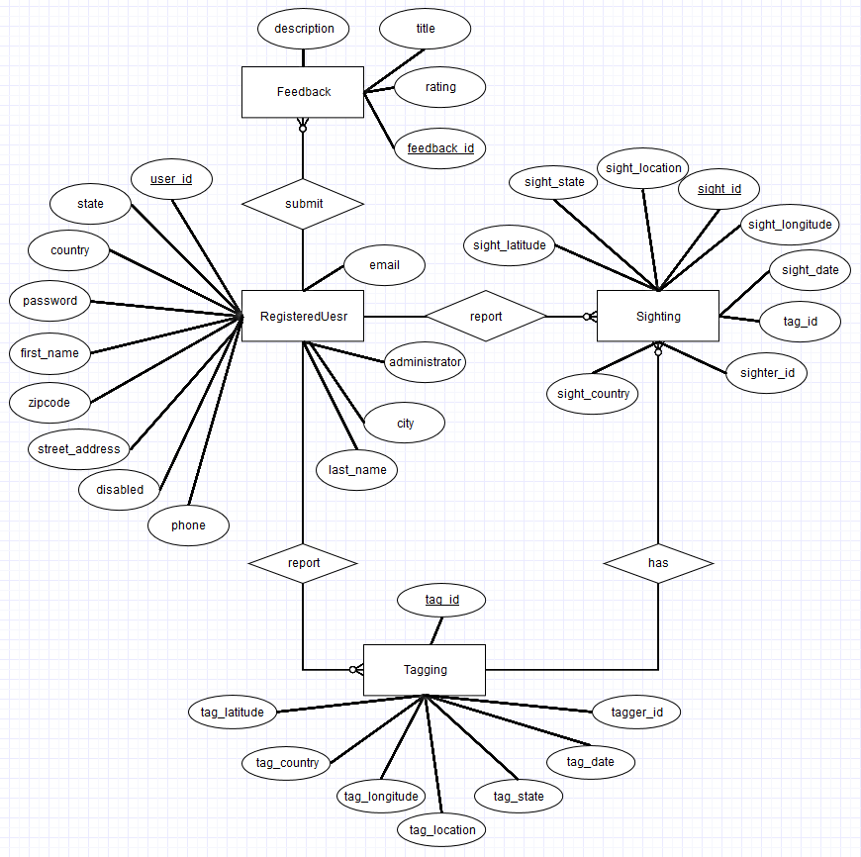
Diagram 3.1.1 Build ERD v1.0 11/22/2015

3.1.2 Data dictionary
See the “Sighting Data Dictionary v1.0.xlsx” file.

4.0 Functional Model and Description

4.1 Description for Function n

4.1.1 Use case name
See section 2.2 for details.

4.2 Software Interface Description
The software interface(s) to the outside world is (are) described.

4.2.1 External machine interfaces
Since the Butterfly Tracking System will run over the internet, all the hardware shall require to connect to the internet will be hardware interface for the system. Examples are Cable/DSL Modem, Router, Ethernet Cable, and so on.

4.2.2 External system interfaces
The Butterfly Tracking System will be able to process batch files containing any number of butterfly taggings and sightings. These files can be uploaded from any system that is connected to the internet with any modern browser installed.
Similarly, the system will enable its users to download batch files containing butterfly tracking information to their system, provided the conditions above are met.

4.2.3 Human interface
The user interface for the Butterfly Tracking System will be compatible with any modern browser, such as Microsoft Edge, Mozilla Firefox, Google Chrome, Apple Safari, Opera, and so on. The user interface will be implemented using tools such as JavaScript, Java Server Pages (JSP), JQuery, CSS 3, and HTML 5.

4.3 Use Case Diagrams
The Use Case Summary document contains all details and use case diagrams. See section 2.0 for more details.

4.4 Sequence Diagrams
See documents SD-1.doc through SD-6.doc for sequence diagrams for UC-1 through UC-6 respectively. For detailed use case specifications see section 2. 0.

4.5 Communication Diagrams
See image files CD-1.png through CD-6.png for communication diagrams for UC-1 through UC-6 respectively. For detailed use case specifications see section 2. 0.

5.0 Behavioral Model and Description
A description of the behavior of the software is presented.

5.1 State Transition Diagrams

5.1.1 State Diagram (SMD-1) for Retrieve Butterfly Reports (UC-1):
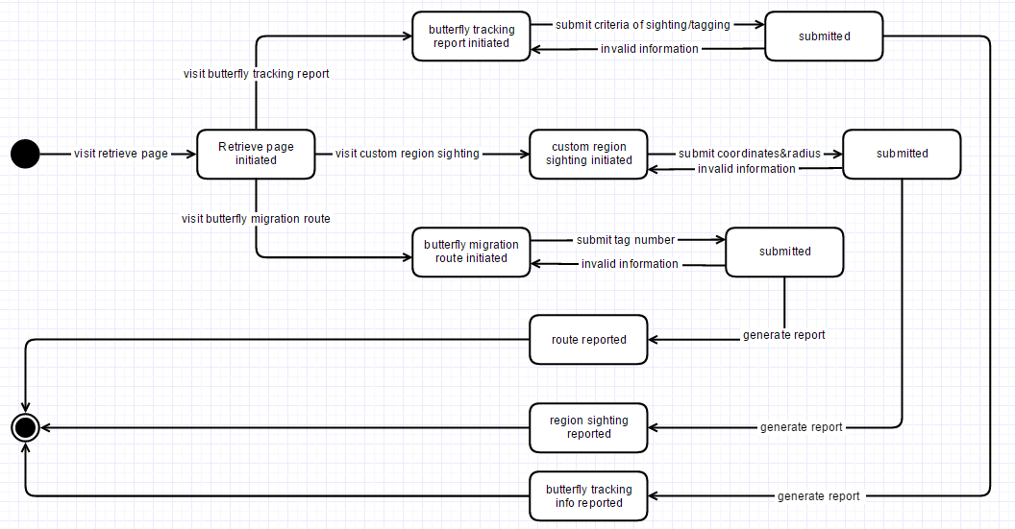
Diagram 5.1.1 SMD-1 version 1.0 11/23/2015

5.1.2 State Diagram (SMD-2) for Session Management (UC-2):
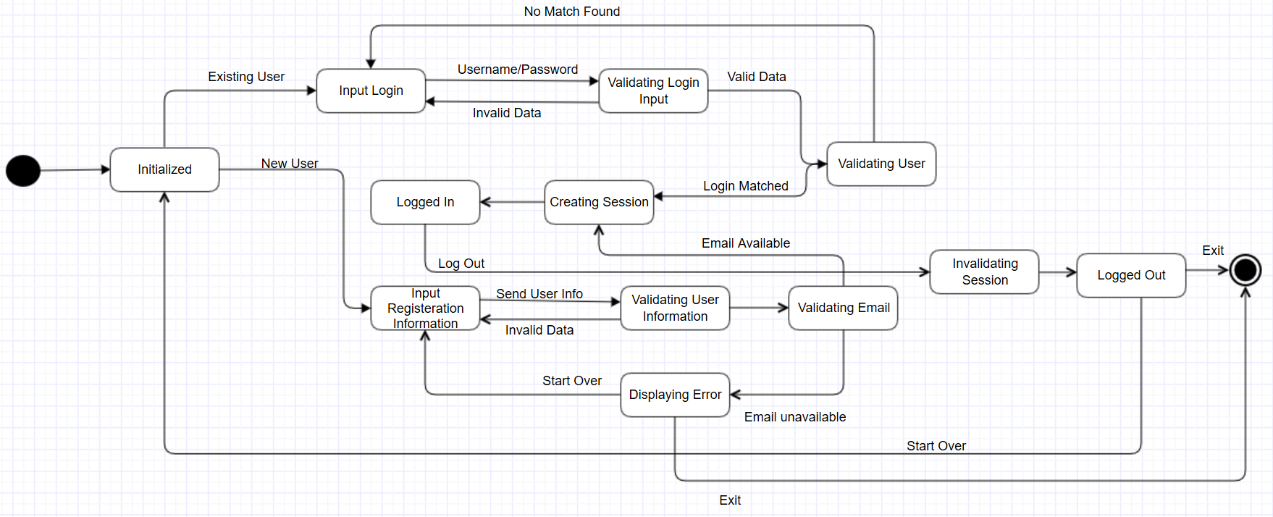
Diagram 5.1.2 SMD-2 version 1.0 11/23/2015

5.1.3State Diagram (SMD-3) for Create Tagging/Sighting (UC-3):
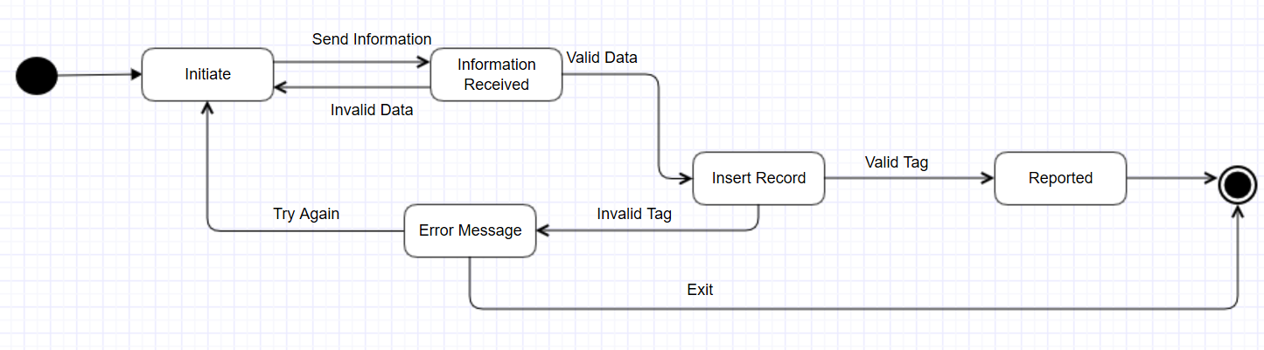
Diagram 5.1.3 SMD-3 version 1.0 11/23/2015

5.1.4 State Diagram (SMD-4) for Update Tagging/Sighting (UC-4):
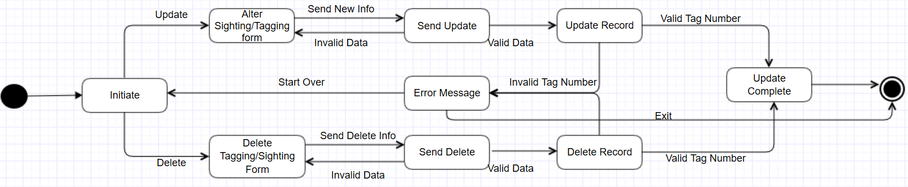
Diagram 5.1.4 SMD-4 version 1.0 11/23/2015

5.1.5 State Diagram (SMD-5) for Administration (UC-5):
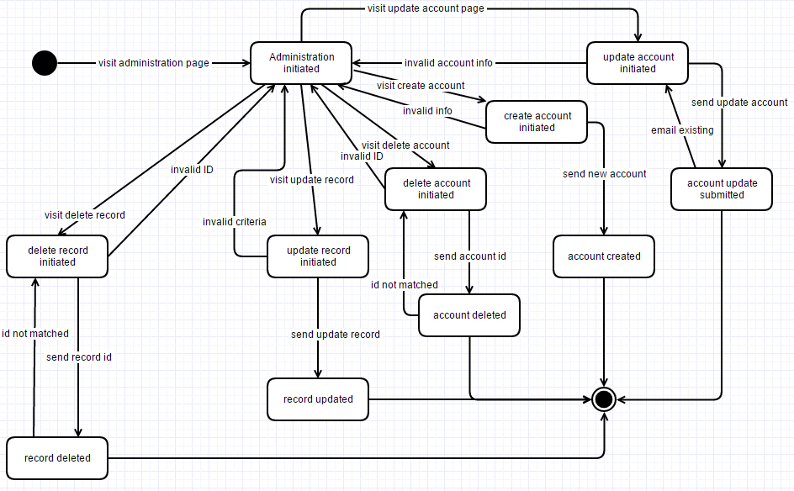
Diagram 5.1.5 SMD-5 version 1.0 11/23/2015

5.1.6 State Diagram (SMD-6) for Submit and View Feedback (UC-6):
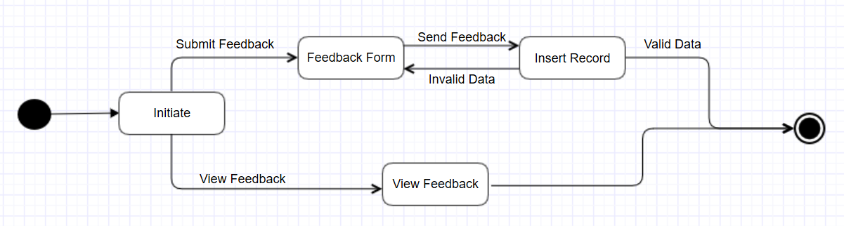
Diagram 5.1.6 SMD-6 version 1.0 11/23/2015

5.2 Activity Diagram
See Use Case Specification Documents for details. Section 2.2 lists all use case documents.

6.0 Restrictions, Limitations, and Constraints
None.

7.0 Validation Criteria

7.1 Classes of tests
The types of tests the team will perform during the development of the Butterfly Tracking System are as follows:
- Unit Testing: To test each and every part of the system in early stages and catch problems in every stage of the development. [1]
- Integration Testing: This will complement unit testing, in that it will allow us to combine multiple program units into one component and test them as a group to ensure program units work properly as a group as well as individually.
- Functional Testing: Applied to ensure each functionality satisfies the requirements regardless of the implementation.
- System Testing: This type of testing will be conducted on the entire system to ensure all requirements are properly met.
More emphasis will be made upon black box testing, and to achieve this we will maintain a usable system throughout the development process and will build upon this system and add functionalities in a maintainable fashion. Doing so will allow us to involve actual target users involved in early stages of the development process in order to get early feedback from users.

7.2 Expected software response
The time taken to login, report or update butterfly tagging or sighting, account management, and any administration task should not take more than 20 seconds from the time the action is initiated by the user until the action is completed. We want the users that use the Butterfly Tracking System to have a pleasant experience and minimize their wait time. However, retrieving various butterfly reports in the form of tables, maps, or files, and uploading and downloading batch files, will be heavily dependent on the size of the report/file, but all effort will be made to maximize the system’s efficiency and minimize user wait time.

7.3 Performance bounds
In addition to what was mentioned in 7.2 regarding system response time, the Butterfly Tracking System will be able to handle multiple connections at a time. The system will have enough resources to meet this requirement.

8.0 Appendices

8.1 System traceability matrix
See the document TraceabilityMatrix.xlsx.

8.2 CRC Cards [2]
Guest
Responsibilities | Collaborations
Register for an account | RegisteredUser
View Tagging Report | RetrieveButterflyReport
View Sighting Report | Feedback
Download Batch File
View/Submit Feedback

RegisteredUser
Responsibilities | Collaborations
View Tagging Report | RetrieveButterflyReport
View Sighting Report | Feedback
Download Batch File | CreateButterflySightingTagging
View/Submit Feedback | UpdateButterflySightingTagging
Report Sighting
Report Tagging
Update Sighting
Update Tagging

Administrator
Responsibilities | Collaborations
View Tagging Report | RetrieveButterflyReport
View Sighting Report | Feedback
View/Submit Feedback | CreateButterflySightingTagging
Report Sighting | UpdateButterflySightingTagging
Report Tagging | Administration
Update Sighting
Update Tagging
Manage User Accounts
Manage All Sightings
Manage All Taggings

Feedback
Responsibilities | Collaborations
Submit Feedback | Guest
View Feedback | RegisteredUser
 | Administrator

Sighting
Responsibilities | Collaborations
Submit Sighting | RetrieveButterflyReport
View Sighting | CreateButterflyTaggingSighting
Update Sighting | UpdateButterflySightingTagging
 | Administration

Tagging
Responsibilities | Collaborations
Submit Tagging | RetrieveButterflyReport
View Tagging | CreateButterflyTaggingSighting
Update Tagging | UpdateButterflySightingTagging
 | Administration

8.3 Class UML Diagram [3]
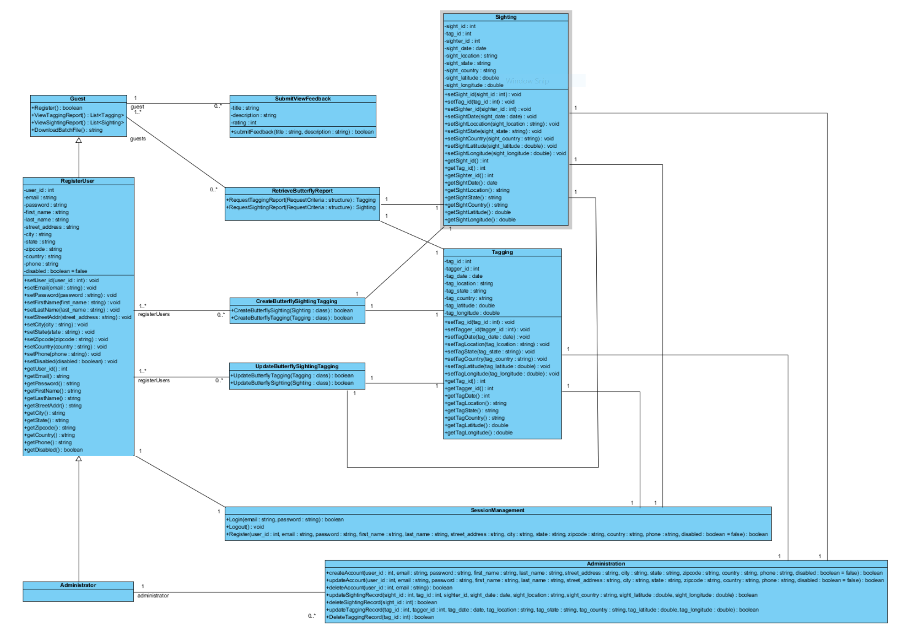

8.4 Context and Data Flow Diagrams
See Context Diagram.png, 0DFD.png, 1DFD.png. 2DFD.png, 3DFD.png, 4DFD.png, 5DFD.png, and 6DFD.png for all Context and Data Flow diagrams.
8.5 References

[1] “Unit Testing”, https://en.wikipedia.org/wiki/Unit_testing [Nov.26, 2015].
[2] Agile Alliance, “Crc Cards”, http://guide.agilealliance.org/guide/crc.html [Nov.28, 2015].
[3] VP Gallery, “Class Diagram”, http://www.visual-paradigm.com/VPGallery/diagrams/Class.html [Nov.27, 2015].

